Assignment (N+) IP Routing and Routing Protocols
Task-1:
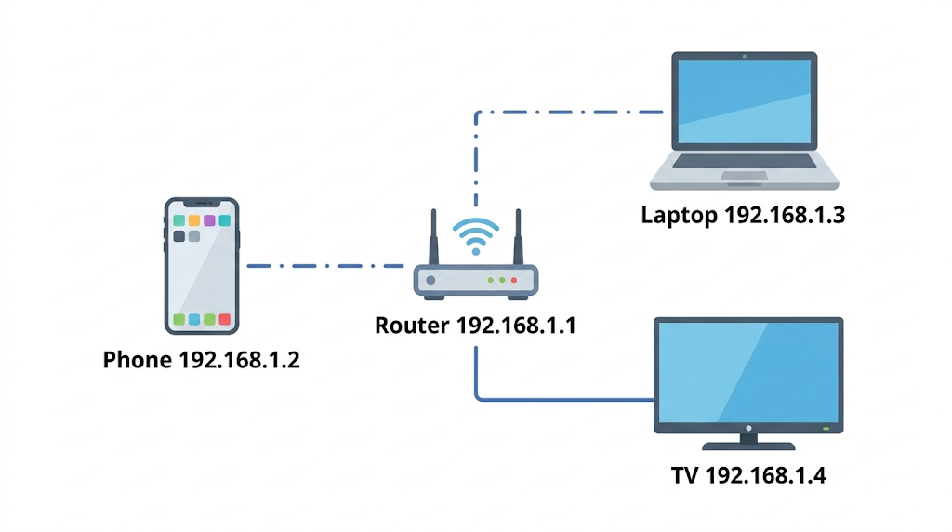

Task-2:
The Setup:
- My Laptop: 192.168.1.10
- My Router (Router A): 192.168.1.1
- Friend's Router (Router B): 172.16.0.2
- Friend's PC: 10.0.0.50
The Journey:
- Leaving My Laptop: My laptop wants to send a photo to 10.0.0.50. It realizes this address is not on my local Wi-Fi network. So, it sends the packet to my default gateway—Router A.
- Router A Makes a Decision: Router A receives the packet and looks at the destination (10.0.0.50). It checks its internal map (the routing table):
  - Routing Table Entry: Target: 10.0.0.0/24 -> Send to Next Hop: 172.16.0.2 (Router B) Following the rule, Router A forwards the packet across the internet to Router B.
- Router B Delivers the Packet: Router B catches the packet and looks at the destination. It checks its own routing table:
  - Routing Table Entry: Target: 10.0.0.0/24 -> Status: Directly Connected Since Router B is the boss of my friend's local network, it knows exactly where the computer is and sends the packet straight to my friend's PC (10.0.0.50).

Task-3:
Branch / Destination Network | Subnet Mask | Next Hop IP | Exit Interface
10.10.1.0 (Rajkot Local) | 255.255.255.0 | Directly Connected | GigabitEthernet0/0
10.10.2.0 (Mumbai Hub) | 255.255.255.0 | 172.16.1.2 | Serial0/0/0
10.10.3.0 (Bangalore Hub) | 255.255.255.0 | 172.16.1.6 | Serial0/0/1
0.0.0.0 (Cloud Servers) | 0.0.0.0 | 203.0.113.1 | GigabitEthernet0/1

Task-4:
Static Routing (Manually typed routes)Pros:
- Highly secure because routers don't broadcast their network maps, making it harder to intercept data.
- Uses almost zero router CPU and memory, which is perfect for small, fixed setups.
- 100% predictable traffic flow—great for testing precise access control lists in Cisco Packet Tracer.Cons:
- No automatic failover; if a cable breaks, your internet drops until an admin manually types a new route.
- Extremely tedious and time-consuming to update as the network grows.
- Unrealistic for large enterprises because human error is too likely when typing hundreds of IPs.
Dynamic Routing (OSPF, RIP - Automatic learning)Pros:
- Automatic failover; if a Zomato backend server in Mumbai suddenly goes offline, OSPF instantly reroutes your food order request to a backup server without the app ever crashing.
- Highly scalable because new routers talk to each other and automatically learn the whole network map.
- Intelligently picks the fastest path based on real-time link speeds, reducing lag.Cons:
- Consumes significantly more router CPU and memory to constantly calculate math algorithms for the best paths.
- Less secure by default, meaning you have to set up extra passwords so rogue devices can't inject fake routes.
- Much harder to troubleshoot if the network gets confused and routes keep constantly shifting back and forth.

Task-5:
Router 1 (R1) OSPF Configuration
enable
configure terminal
router ospf 1
network 10.0.0.0 0.0.0.3 area 0
network 192.168.1.0 0.0.0.255 area 0
Router 2 (R2) OSPF Configuration
enable
configure terminal
router ospf 1
network 10.0.0.0 0.0.0.3 area 0
network 172.16.1.0 0.0.0.255 area 0
Configuration Line Explanations
- enable and configure terminal: These commands move the router from basic user mode into global configuration mode, granting the administrative access required to modify network routing protocols.
- router ospf 1: This activates the OSPF routing protocol on the device. The 1 is the Process ID, which is just a local tag used by the router's CPU to manage the process. It does not need to match the neighboring router, though admins often match them for simplicity.
- network 10.0.0.0 0.0.0.3 area 0: This targets the direct connection between Router 1 and Router 2 (a /30 point-to-point subnet). It tells the router to enable OSPF on the interface holding this IP, allowing it to send "Hello" packets and form a neighbor relationship.
- network 192.168.1.0 0.0.0.255 area 0: This line tells the router to advertise its local LAN network (e.g., connected computers or servers) to the OSPF neighbors so they know how to reach it. The 0.0.0.255 is a wildcard mask, representing a standard /24 subnet.
- area 0: This assigns the configured interfaces to the OSPF Backbone Area. In OSPF design, Area 0 is the core hub, and all routing information must pass through it.
Verification: Once configured on both sides, type show ip ospf neighbor in privileged mode. You should see the other router listed with a state of FULL, indicating a successful routing exchange.

